**Global Temperature Dataset Project CSC 465 Spring**

**Prabhakaran Raghavan**

**Abstract:**

To understand the Temperature change over the last 2 centuries. This Dataset has Average temperature data for 7 different countries and its states from the year 1740 in Average Temp in Celsius

1. **Data Exploration:**

This dataset has 645675 rows and 5 Variables (Date, AverageTemperature, AverageTemperatureUncertainty, State, Country).

AverageTemperature and AverageTemperatureUncertainty is in Celsius, AverageTemperature (Dependent variable) is the focus of our Project for Data visualization. Project main goal is to find out whether the temperature is rising? For which Independent variables are Date,Country and State, while AverageTemperatureUncertainty could be considered as noise.

> summary(GlobalLandTemperaturesByState)

dt AverageTemperature AverageTemperatureUncertainty

Min. :1743-11-01 Min. :-45.389 Min. : 0.036

1st Qu.:1845-12-01 1st Qu.: -0.693 1st Qu.: 0.316

Median :1902-02-01 Median : 11.199 Median : 0.656

Mean :1898-10-01 Mean : 8.993 Mean : 1.288

3rd Qu.:1957-12-01 3rd Qu.: 19.899 3rd Qu.: 1.850

Max. :2013-09-01 Max. : 36.339 Max. :12.646

NA's :25648 NA's :25648

State Country Month Month.String

Length:645675 Length:645675 Min. : 1.000 Length:645675

Class :character Class :character 1st Qu.: 3.000 Class :character

Mode :character Mode :character Median : 6.000 Mode :character

Mean : 6.498

3rd Qu.: 9.000

Max. :12.000

Year

Min. :1743

1st Qu.:1845

Median :1902

Mean :1898

3rd Qu.:1957

Max. :2013

Variables introduced for the analysis are Month,Month.String and Year.

> describe(GlobalLandTemperaturesByState)

GlobalLandTemperaturesByState

8 Variables 645675 Observations

dt

n missing unique

645675 0 3239

lowest : 1743-11-01 1743-12-01 1744-01-01 1744-02-01 1744-03-01

highest: 2013-05-01 2013-06-01 2013-07-01 2013-08-01 2013-09-01

AverageTemperature

n missing unique Info Mean .05 .10 .25 .50 .75

620027 25648 100924 1 8.993 -15.828 -10.354 -0.693 11.199 19.899

.90 .95

25.659 27.296

lowest : -45.39 -44.74 -44.72 -44.59 -44.45

highest: 35.99 36.01 36.20 36.29 36.34

AverageTemperatureUncertainty

n missing unique Info Mean .05 .10 .25 .50 .75

620027 25648 8040 1 1.288 0.179 0.216 0.316 0.656 1.850

.90 .95

3.417 4.169

lowest : 0.036 0.037 0.041 0.042 0.044

highest: 11.914 12.060 12.189 12.352 12.646

State

n missing unique

645675 0 241

lowest : Acre Adygey Aga Buryat Alabama Alagoas

highest: Yaroslavl' Yevrey Yukon Yunnan Zhejiang

Country

n missing unique

645675 0 7

Australia Brazil Canada China India Russia United States

Frequency 16102 34328 35358 68506 86664 254972 149745

% 2 5 5 11 13 39 23

Month

n missing unique Info Mean .05 .10 .25 .50 .75

645675 0 12 0.99 6.498 1 2 3 6 9

.90 .95

11 12

1 2 3 4 5 6 7 8 9 10 11 12

Frequency 53808 53812 53828 53833 53842 53843 53844 53872 53882 53643 53734 53734

% 8 8 8 8 8 8 8 8 8 8 8 8

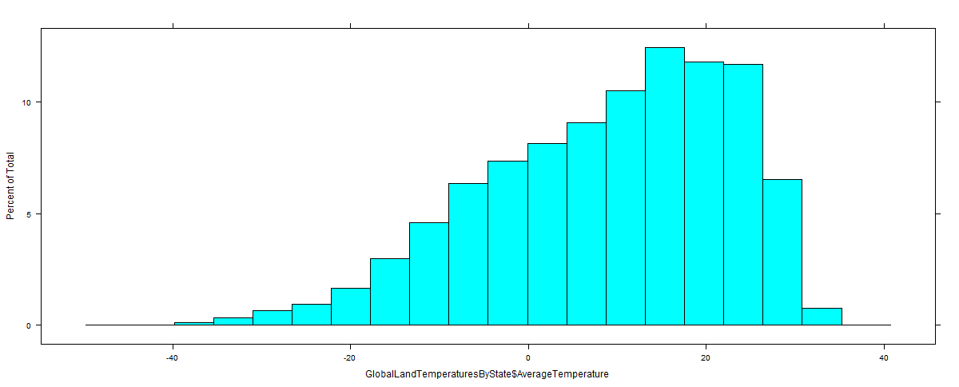

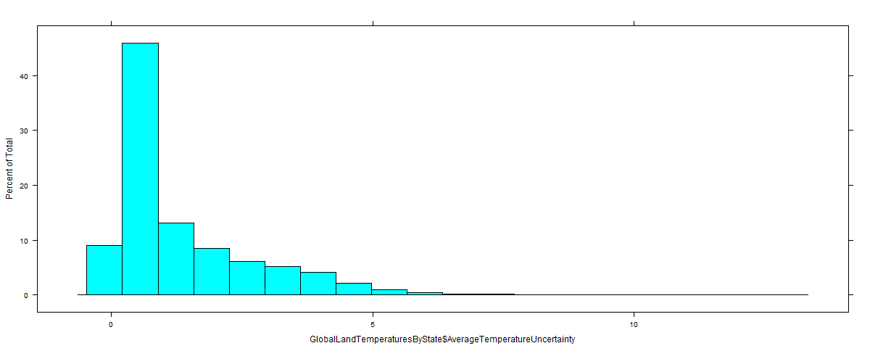

Looking at initial histogram during data exploration the data

AverageTemperature is more skewed towards above 10 degree Celsius.

**b) Visualization techniques:**

The dataset has significant amount of data with 250 years of data. Timeseries Graph was the first thing would like try. Then since it 7 countries (with its State level data) data Geospatial / Choropleth map are

Good use for this dataset. After intial analysis the question tried to answer ”Is the temperature rising?”. If so what are the plots would help answer the question.

Initial Plots and Analysis were line graph since it has time series data and so it would enable to find more details about each country’s Avg temperature trends.



Had a treemap for different countries from 1745

Created a uncertainty linear graph from 1745 to understand the data Average temperature uncertainty and its signficance on the Average temperature.



With the Uncertainty graph shows that from 1750 till 1900s there is signficant change in Actual AverageTemperature if we add the AverageTemperature Uncertainty.

**Approach I:**

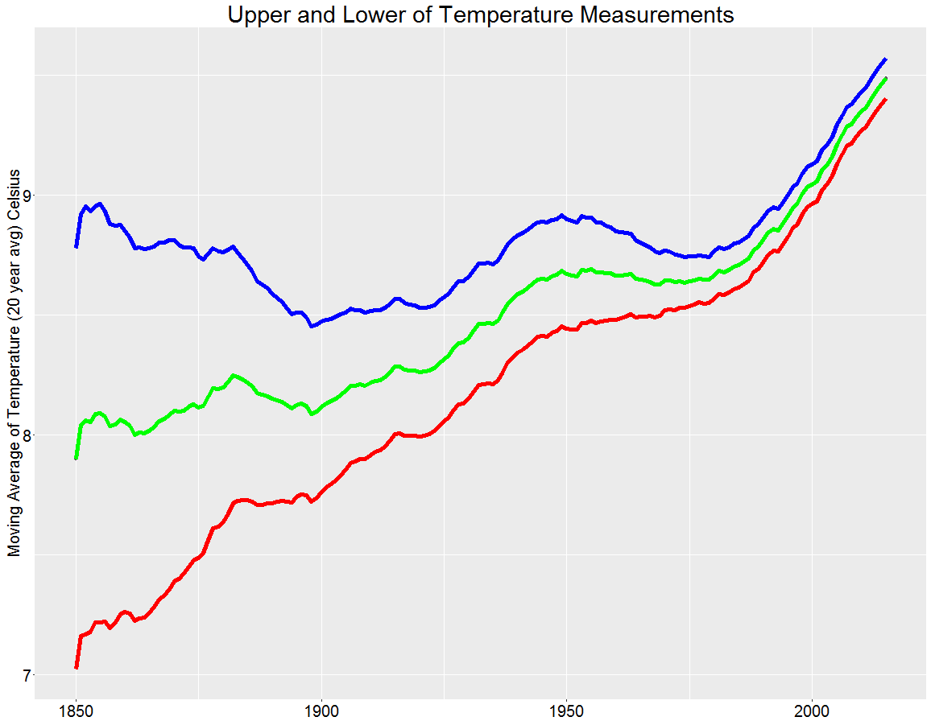

So this made to start deeper analysis of data from 1960s onwards which is of ±.09 celisus degree change in Avg temperature. Here the graph is plotted with green line is the actual AverageTemperature and Red and Blue line is got by adding and subtracting AveragetempUncertainty

Initial Cholorpeth was per year graph

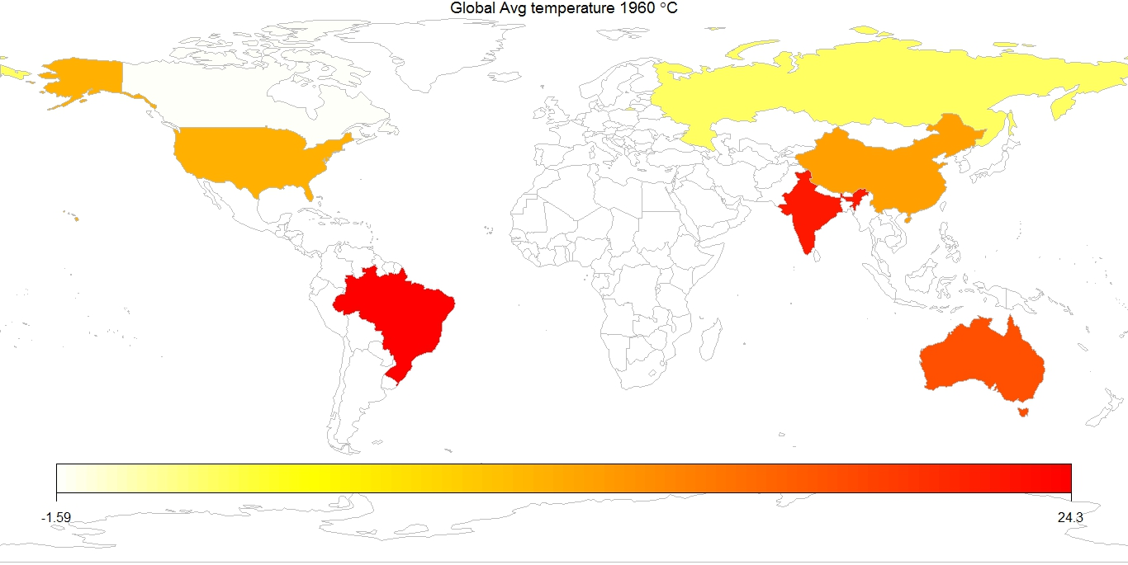

Here choropleth map to present the average temp for a year for different countries, here since only 7

Countries are there most of the Map looks not filled.

So which does not give the full picture of how the avg temperature changed over the years.

So decided to have Choropleth map for Decade to show the Average temperature for 7 countries. This is show how the AverageTemperature has increased for different countries from 1940 to the present 20

Years.



Here also it was too may maps and color used were divergent which did not give clear message.

Here below I had to explore find the Density of Avg temperature throughout the year using visually to

show the change



The above graph show the change in Avg temperature over the the years and it show the higher density of higher average temperature from 1960s.

**Approach II**

Now decided to make the choropleth for 20 years intead of 10 years and which show clearly analysis country level Average temperature fared from 1960. Tried the Choropleth graph

With country Avg temp from 20 years from 1960 – 79 and 1980 – 2013.

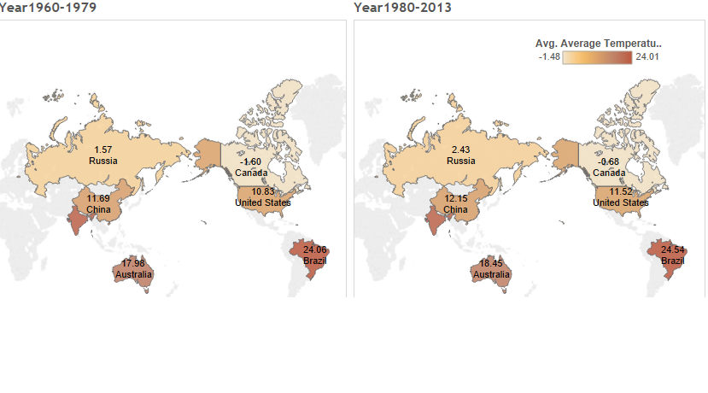

Here we could clearly see the Avg temperature has increased for all 7 countries. We are seeing signficant temperature change for Canada,Russia and USA. The color used is sequential with single color saturation. It is done using Tableau Dashboard.

Now we know the temperature are increasing annualy , wanted to create visualization to have monthly change for the each countries.

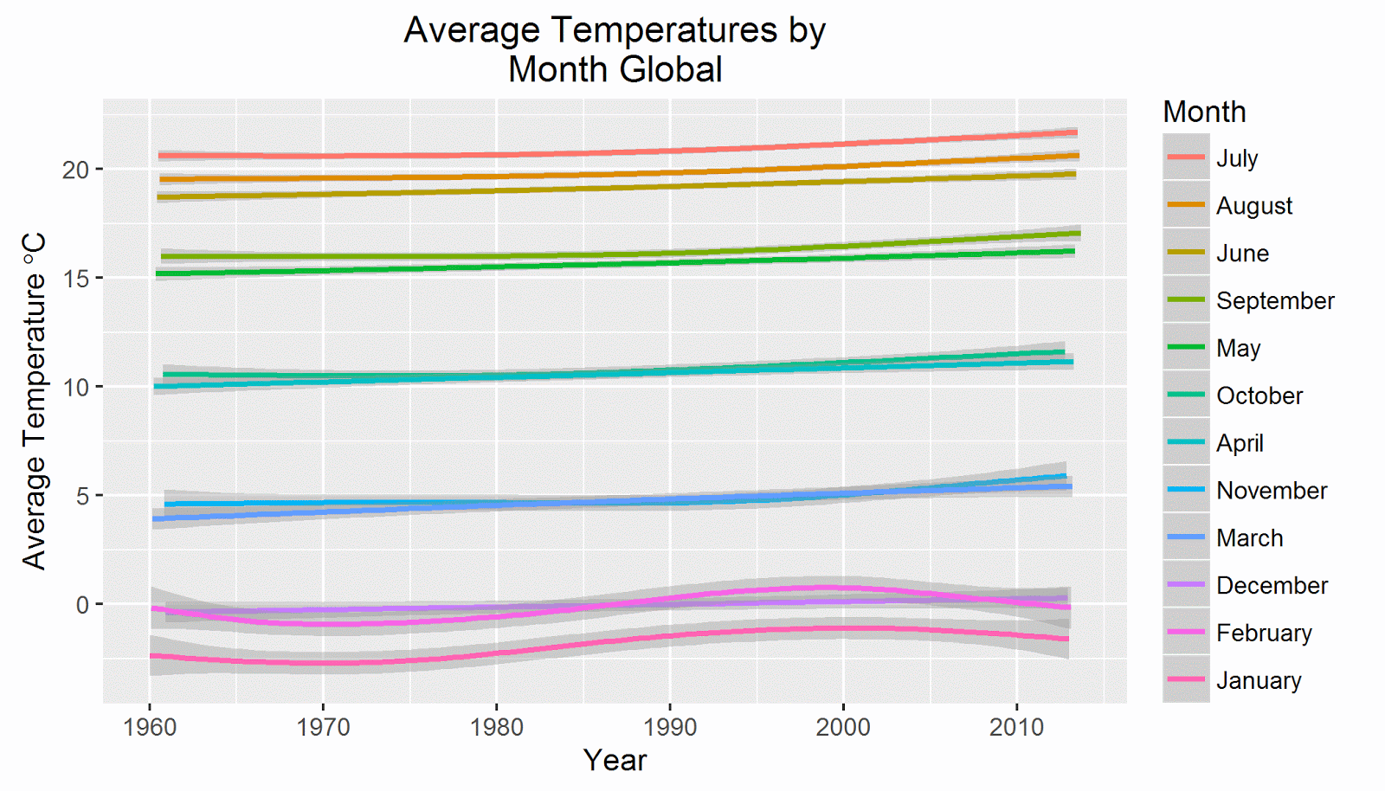

Linear graph clearly show the temperature has increased for every month from 1960.Here the 12 different colors for 12 months .It was build using ggplot.

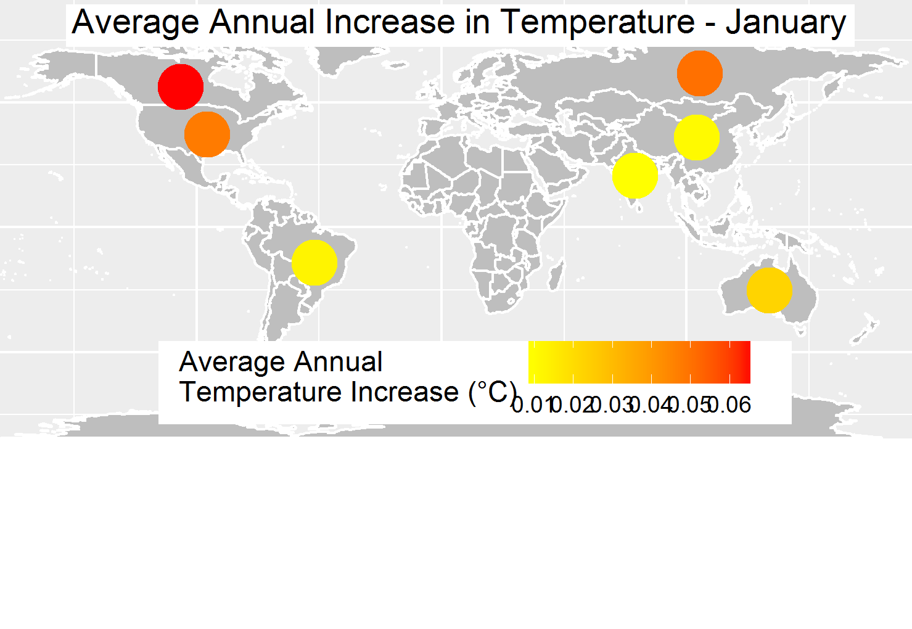

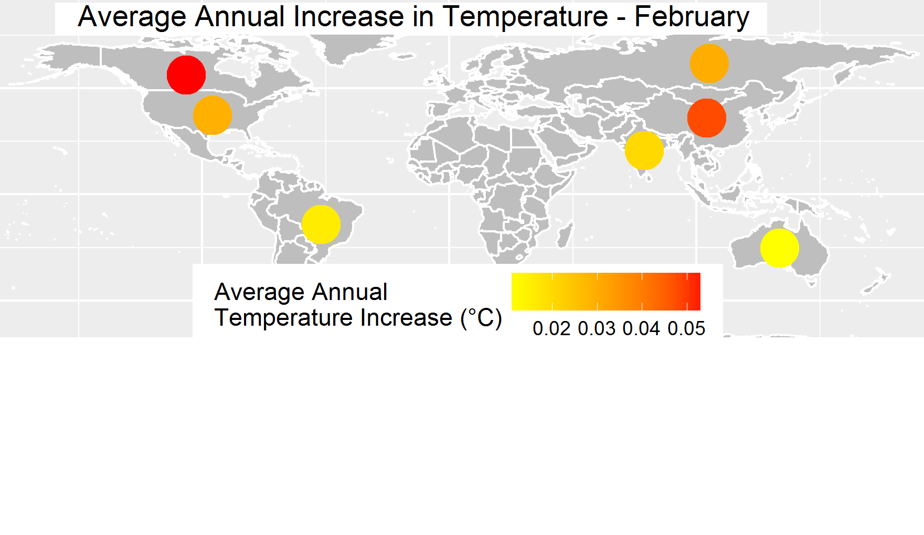

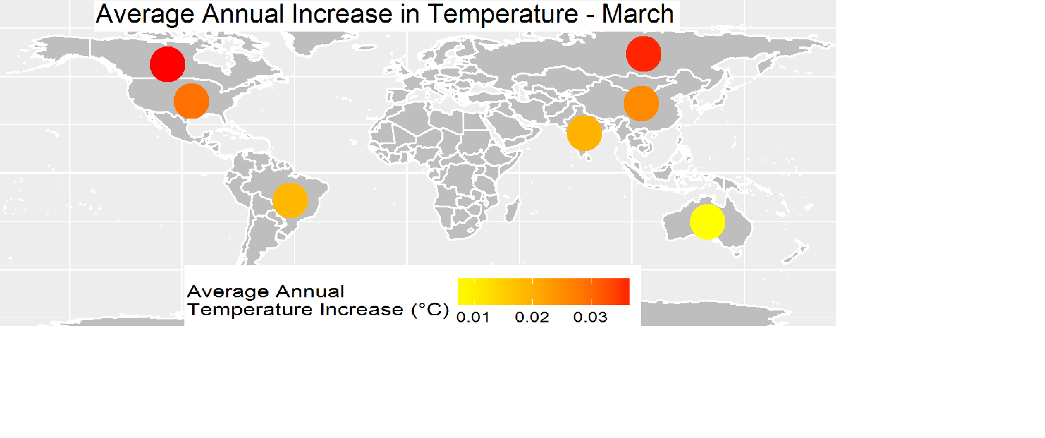

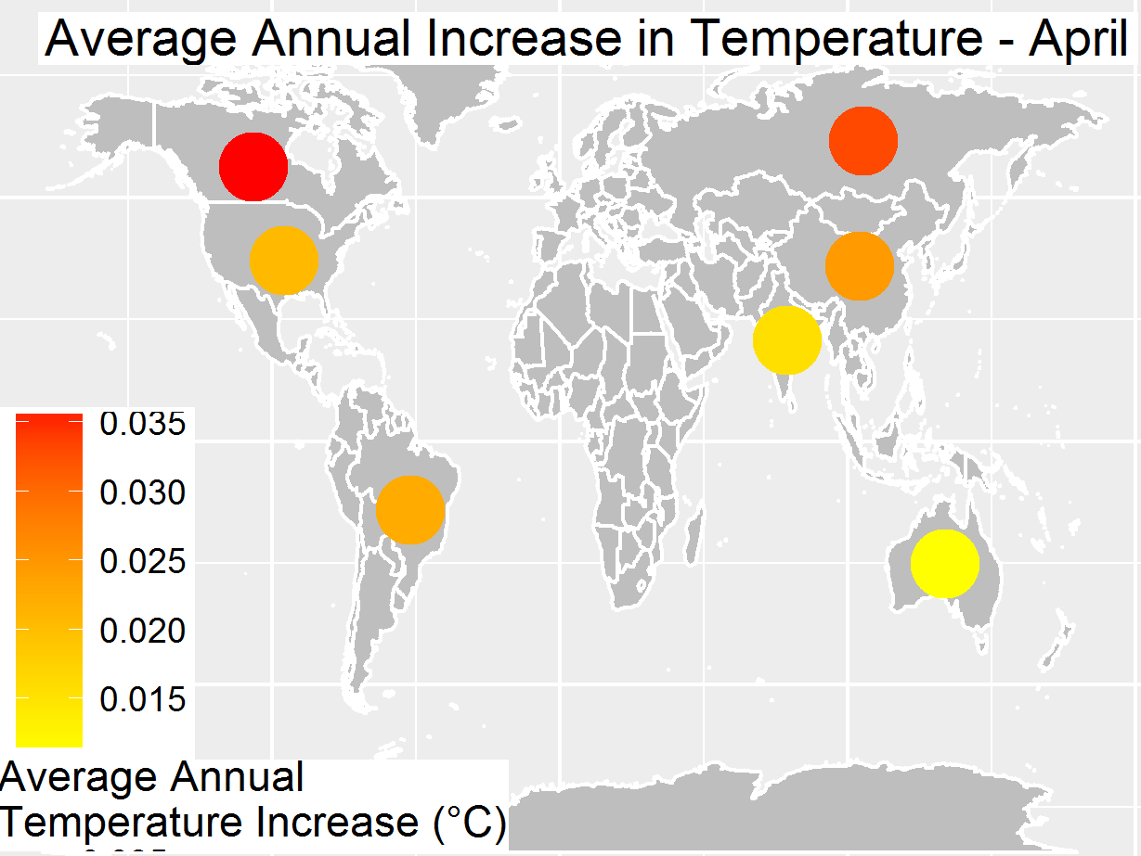

Here it was decided to have world map and point the Monthly Avg temperature Increase per country. Decided to use point to avoid too much color and want show the clear difference between the countries for the month. Colors used are Yellow, orange to red. Red signifies the highest average temp increase while yellow shows the lowest increase. It was done with R with lm function for Avg Temp~ country + month.

This clearly show every month there is change in Average Temperature over the last 50 years.



Created Choropleth map to show the change in Average temperature for US States from 1960

It is animated to show the Average temperature change over the last 50 years. It shows the temperature changes in the northern states. Used 8 color sequential to show the difference in temperature across the 50 states.

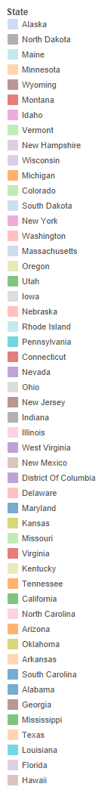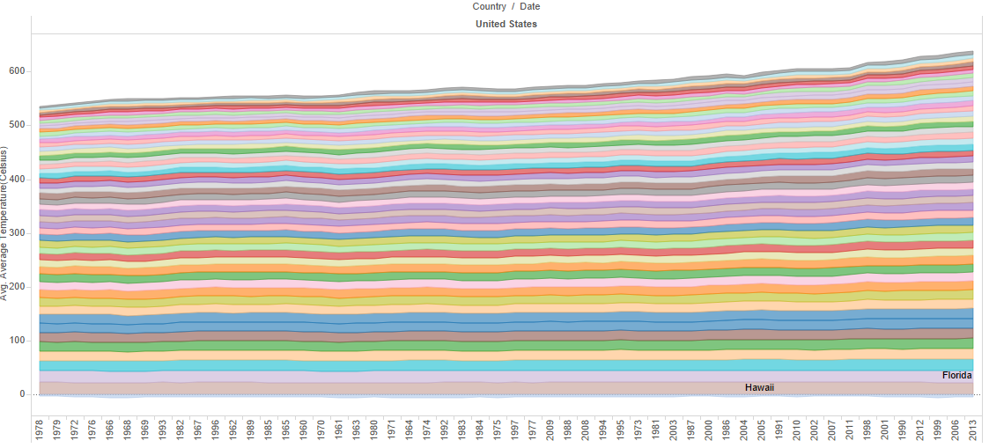



Here this graph shows the 50 states (50 different colors) average temperature has increased over the last years. Lowest temperature was in 1978 and highest in 2013.

**Approach III**

**c)Refined Techniques**

There were few things has been suggested for Choropleth Decades Avg. temp change for the countries , for the US states animation is for the Average temperature from 1960 it was not providing Visually change in Avg temp for the US States. Also for the US states Cummulative Avg temperature with 50 different color was not reaching the audience. So decided to those Plots.

Made the changes necessary in the choropleth map has to be of same time period and also color for the Avg temperature is Divergent instead of Sequential

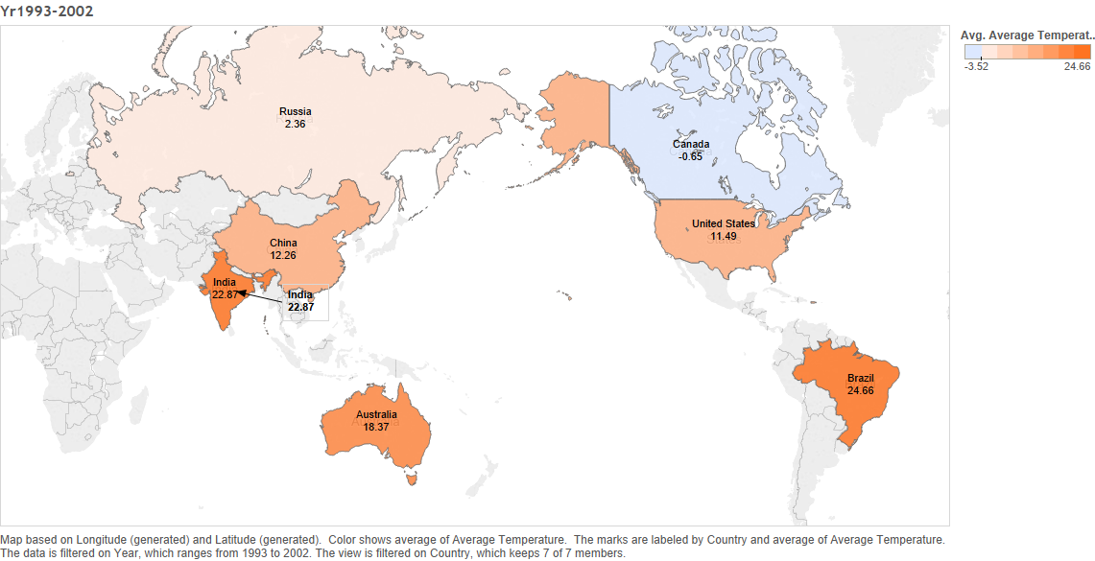

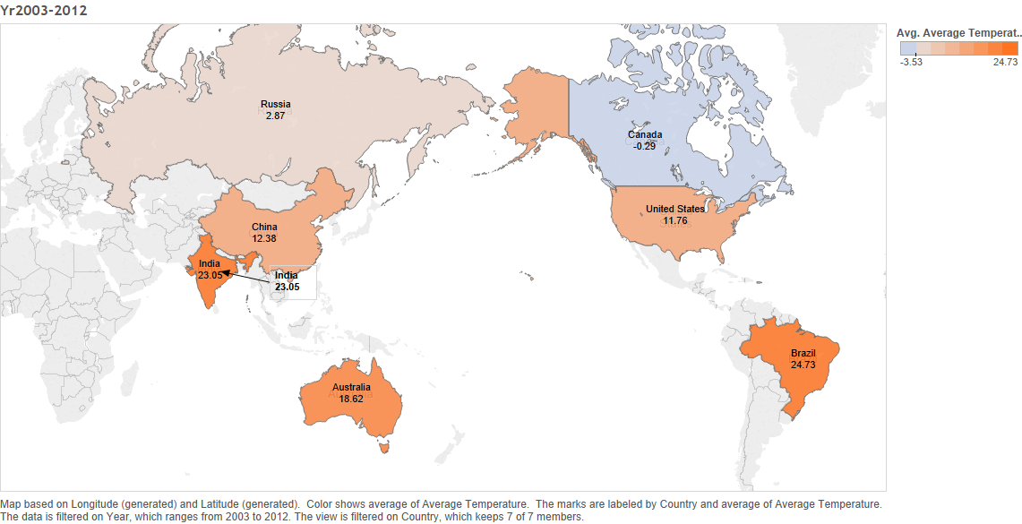

Next suggestion is to make the AverageTemp Monthly linear graph with seasoned coloring . So is the changed plot.

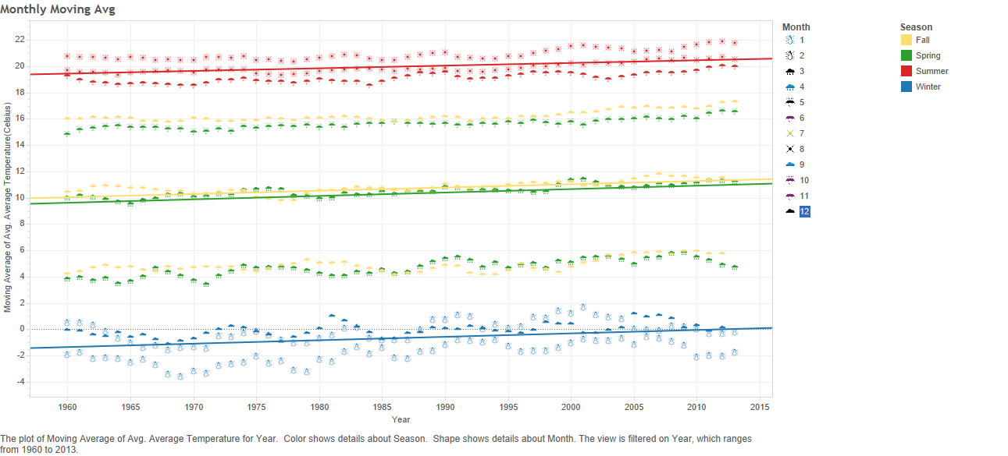

One more thing changed was the US State Animation was changed to show the Year over year change in Avg temperature for different states.



Modified the Cummulative US 50 state Avg temperature from line graph to a choropleth to show running total with diveregent colors for Avg temperature for the States.

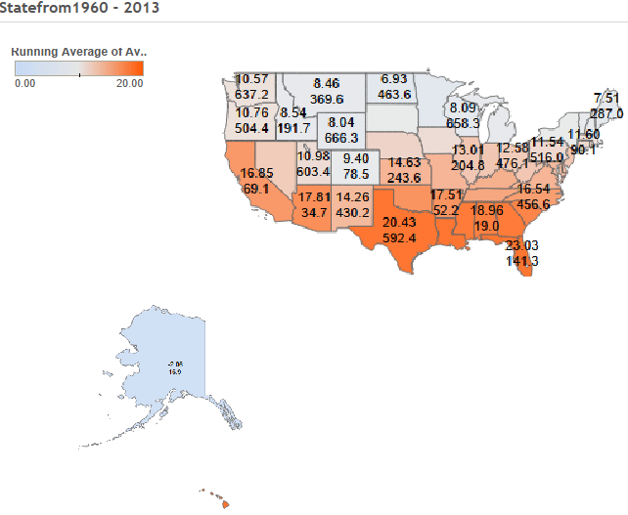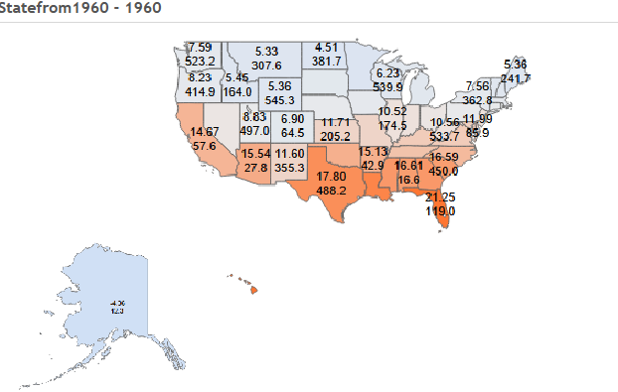

1. **Analysis and results**

With the help of various graphs and plots did the analysis to answer the question

“Is the temperature rising?”

Initial linear graphs have shown the global Average temperature is trending higher. Graph with Average Temperature uncertainties shows that 1700s and 1800s has significant impact on the actual Average temperature. So decided to do analysis from 1960s to find the answer the question “Is the temperature rising?”.

With the help of choropleth map we could really see from 1992s to 2012, the Avg. temperature for 7 the countries has increased.

Russia  0.51 Celsius ,Canada 0.36 Celsius, U.S.A 0.27 Celsius

With the help of monthly Average temperature choropleth map it shows every month the temperature is increasing, significant increase is for the months of January, February and December.

Also it shows Canada, Russia and United states are increasing more. It also shows Northern Hemisphere Countries are increasing the Average temperature since 1993s .

With the help of the density plot for the Average temperature also confirms that over the years, temperature has increased. Density has increased more from 1960s.

Choropleth map for US 50 states shows the Year over Year change in temperature from 1960s.

Here for Map US States Avg temp Visually we could see changes are mostly in every region of US. Average Temperature. In 1990s the Average temp on the East coast states have increased.In 1960s the Northern states Avg temperature has increased. In 1980s Western and South western states Avg temperature trend increased

In US the during1960 Total 50 states had cumulative total average temperature was 545 Celsius,

now in 2013 Total cumulative 666 Celsius. It clearly show the average temperature of most of the 50

states has increasing trend.

Here is a violin plot with Monthly distribution of temperature in 1960

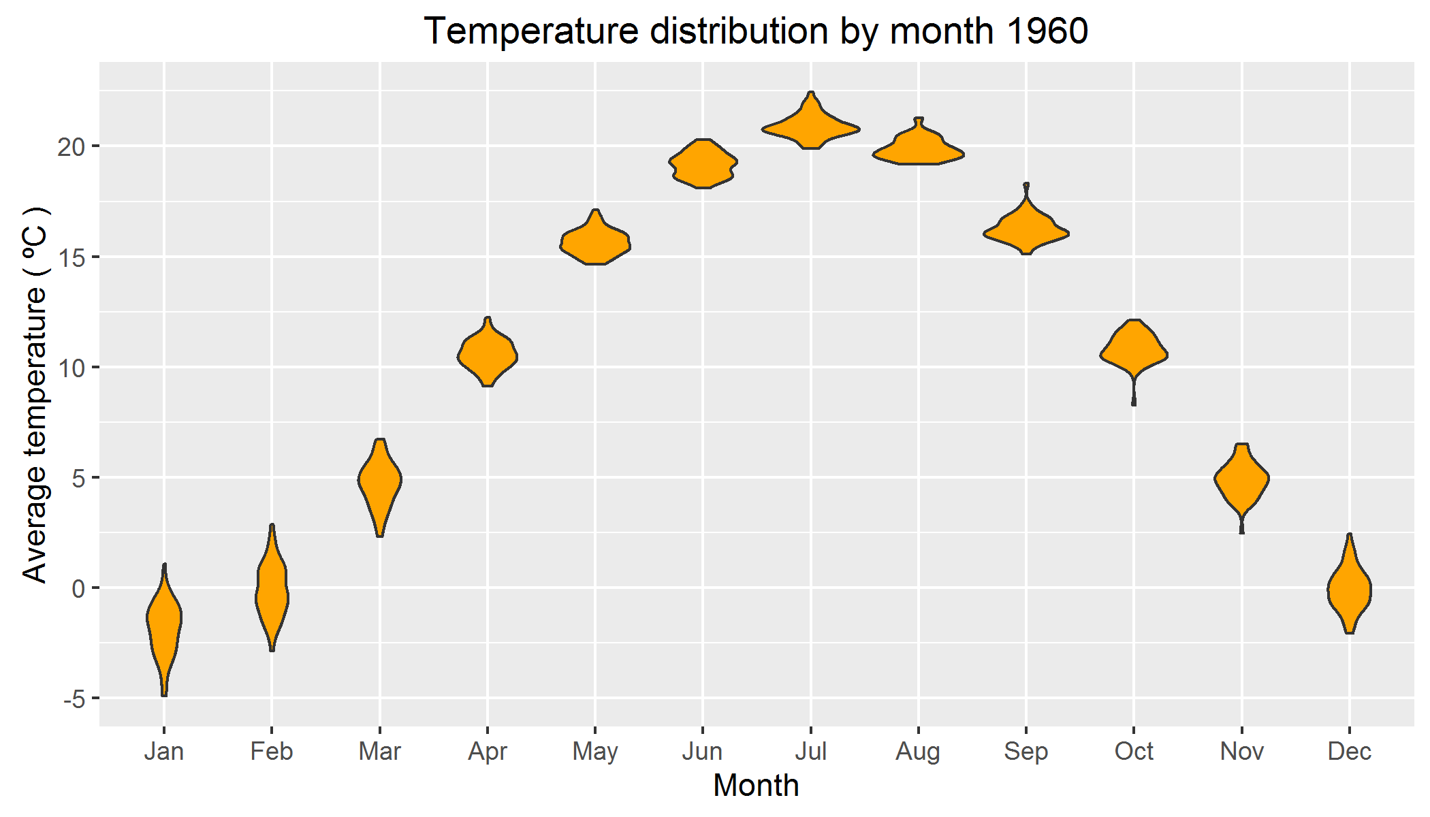

So with the data analysis and plots used we are good to say Average temperature is increasing over last 50 years. This data shows that temperature is rising. So we answer the question “Is the temperature rising?” we could say “YES”. It is a fact it is trending higher. Have not seen data which show that temperature is going down.

1. Appendix

Prab:

I have attached the R code and Tableau Code in drop box. I have learned many things in this course, R ggplot2 , choropleth. Tried few of the packages googleVis,zoo and Json formats. Tableau was used for creating Dashboard and even tried to publish the

Work to public.tableau.com.

With this course now, I would be able to generate plot with proper data visualization using proper color and correct plots.

Source code of R

library(ggplot2) # Data visualization

#library(readr) # CSV file I/O, e.g. the read_csv function

library(animation)

library(ggplot2)

library(maptools)

library(rgeos)

library(Cairo)

library(ggmap)

library(scales)

library(RColorBrewer)

library(choroplethrMaps)

library(choroplethr)

library(maps)

library(data.table)

library(dplyr)

library(statebins)

library(SGP)

library(rgdal)

library(rworldmap)

ani.options(convert = 'convert.exe')

GlobalLandTemperaturesByState <- fread("c:/CSC465/project/GlobalLandTemperaturesByState.csv")

#city <- read.csv("../input/GlobalLandTemperaturesByCity.csv")

GlobalLandTemperaturesByState$year <- substr(GlobalLandTemperaturesByState$dt,1,4)

allYears <- unique(GlobalLandTemperaturesByState$year)

USData<-GlobalLandTemperaturesByState[GlobalLandTemperaturesByState$Country=='United States']

head(USData)

USData1 <- aggregate(AverageTemperature~year+State,USData,mean)

head(USData1)

library(stringi)

USData1$State<- as.character(USData1$State)

USData1$State[USData1$State=="Georgia (State)"]<-"Georgia"

USData1$State<- as.factor(USData1$State)

USData5<-data.table(USData1)

USData5[, yoy := c(NA, diff(USData5$AverageTemperature)), by = "State"]

typeof(USData5$AverageTemperature)

USData5$yoy=as.numeric(USData5$yoy)

head(USData5)

datm <- melt(USData1, 'year',

USData1.name = 'region',

value.name = 'State'

# USData1.name = 'AverageTemperature',

# value1.name = 'AverageTemperature'

)

head(datm)

#,n=12500)

choropleths = list()

for (i in 2:ncol(datm)) {

df = datm[, c(1, i)]

colnames(df) = c("region", "value")

title = paste0("US Temp: ", colnames(USData1)[i])

choropleths[[i-1]] = state_choropleth(df, title=title)

}

library(choroplethr)

library(choroplethrMaps)

library(sqldf)

library(tcltk)

head(USData)

USData4<-

sqldf("

select

year,State

,avg(AverageTemperature) as value

from USData

group by

State,year

")

USData6<-

sqldf("

select

year,State

,yoy as value

from USData5

where year >1959

group by

State,year

")

#USData %>%

# select(year,AverageTemperature,State) %>%

# group_by(year,State) %>%

# summarise(value=mean(AverageTemperature))-> USData4

USData4$State<- as.character(USData4$State)

USData4$State[USData4$State=="Georgia (State)"]<-"Georgia"

USData4$State<- as.factor(USData4$State)

USData6$State<- as.character(USData6$State)

USData6$State[USData6$State=="Georgia (State)"]<-"Georgia"

USData6$State<- as.factor(USData6$State)

colnames(USData4)[2]<- "region"

USData4$region<-tolower(USData4$region)

head(USData)

USData4 <- na.omit(USData4)

colnames(USData6)[2]<- "region"

USData6$region<-tolower(USData6$region)

head(USData)

USData6 <- na.omit(USData6)

head(USData4)

dev.off()

print(state_choropleth(USData4[USData4$year==1900],

title="Land Temperature 1900",

num_colors = 8,

legend="Degrees"),reference_map=TRUE)

saveGIF({

for (thisYear in 1960:2013 ) {

thisYearCountry <- USData4[USData4$year == thisYear, ]

thisYearCountry <- na.omit(thisYearCountry)

print(state_choropleth(thisYearCountry,

title=paste("Avg. Temp in US", thisYear),

num_colors = 8,

#brewer_pal="YlOrRd",

legend="Degrees"),reference_map=TRUE)

}

}, interval = 0.3, movie.name = "tempDensity3.gif", ani.width = 800, ani.height = 600)

saveGIF({

for (thisYear in 1960:2013 ) {

thisYearCountry <- USData6[USData6$year == thisYear, ]

thisYearCountry <- na.omit(thisYearCountry)

print(state_choropleth(thisYearCountry,

title=paste("Year over year Avg Temp change in US", thisYear),

num_colors = 8,

#brewer_pal="YlOrRd",

legend="Degrees"),reference_map=TRUE)

}

}, interval = 0.3, movie.name = "tempYoy1.gif", ani.width = 800, ani.height = 600)

saveGIF({

for (thisYear in 1960:2013 ) {

thisYearCountry <- USData4[USData4$year == thisYear, ]

thisYearCountry <- na.omit(thisYearCountry)

#stateData$value=thisYearCountry$value[!sapply(thisYearCountry, is.null)]

choro = StateChoropleth$new(na.omit(thisYearCountry))

choro$title = paste("Avg. Temp in US", thisYear)

choro$ggplot_scale = scale_fill_brewer(name="Avg. temp Degrees"~degree~C, palette="Purples", drop=FALSE)

choro$render()

}

}, interval = 0.3, movie.name = "tempDensity2.gif", ani.width = 800, ani.height = 600)

#saveGIF({

setwd('C:/CSC465/Project/images')

for (thisYear in 1960:2013 ) {

thisYearCountry <- USData4[USData4$year == thisYear, ]

thisYearCountry <- na.omit(thisYearCountry)

if (thisYear >= 1960) {name = paste('US', thisYear,'plot.png', sep='')}

#if (i < 10) {name = paste('000',i,'plot.png',sep='')}

#if (i < 100 && i >= 10) {name = paste('00',i,'plot.png', sep='')}

choro = StateChoropleth$new(na.omit(thisYearCountry))

choro$title = paste("Avg. Temp in US", thisYear)

choro$ggplot_scale = scale_fill_brewer(name="Avg. temp Degrees"~degree~C, palette="Purples", drop=FALSE)

choro$render()

#$render()

if (thisYear >= 1960) {name = paste('US', thisYear,'plot60.png', sep='')}

png(name)

dev.off()

}

#install.packages('animation', repos = 'http://yihui.name/xran')

#library(animation)

data(thisYearCountry.regions)

head(thisYearCountry)

saveGIF({

for (thisYear in allYears) {

thisYearCountry <- GlobalLandTemperaturesByState[GlobalLandTemperaturesByState$year == thisYear, ]

m <- ggplot(thisYearCountry, aes(x=AverageTemperature))

m <- m + ggtitle(paste("Country - Average Temperature Histogram -", thisYear))

m <- m + geom_density(alpha=.5, fill = "gray")

m <- m + xlim(c(-40, 50))

m <- m + ylim(c(0, .05))

m <- m + geom_vline(aes(xintercept=mean(AverageTemperature, na.rm=T)), # Ignore NA values for mean

color="red", linetype="dashed", size=1)

m <- m + geom_vline(aes(xintercept=median(AverageTemperature, na.rm=T)), # Ignore NA values for mean

color="blue", linetype="dashed", size=1)

print(m)

}

}, interval = 0.6, movie.name = "tempDensity6.gif", ani.width = 800, ani.height = 600)

World temp change from 1960 R source code

library(ggplot2)

library(maptools)

library(rgeos)

library(Cairo)

library(ggmap)

library(scales)

library(RColorBrewer)

library(choroplethrMaps)

library(choroplethr)

library(maps)

library(data.table)

library(dplyr)

library(statebins)

library(SGP)

library(rgdal)

library(rworldmap)

typeof(GlobalLandTemperaturesByState$AverageTemperature)

GlobalLandTemperaturesByState <- fread("c:/CSC465/project/GlobalLandTemperaturesByState.csv")

GlobalLandTemperaturesByState1 <- fread("c:/CSC465/project/GlobalLandTemperaturesByState1.csv")

head(GlobalLandTemperaturesByState)

GlobalLandTemperaturesByState$dt<-as.Date(GlobalLandTemperaturesByState$dt,"%Y-%m-%d")

GlobalLandTemperaturesByState$Month<-as.numeric(format(GlobalLandTemperaturesByState$dt,"%m"))

GlobalLandTemperaturesByState$Month.String<-format(GlobalLandTemperaturesByState$dt,"%B")

GlobalLandTemperaturesByState$Year<-as.numeric(format(GlobalLandTemperaturesByState$dt,"%Y"))

GlobalLandTemperaturesByState1$dt<-as.Date(GlobalLandTemperaturesByState1$dt,"%Y-%m-%d")

GlobalLandTemperaturesByState1$Month<-as.numeric(format(GlobalLandTemperaturesByState1$dt,"%m"))

GlobalLandTemperaturesByState1$Month.String<-format(GlobalLandTemperaturesByState1$dt,"%B")

GlobalLandTemperaturesByState1$Year<-as.numeric(format(GlobalLandTemperaturesByState1$dt,"%Y"))

head(GlobalLandTemperaturesByState1)

data11<-GlobalLandTemperaturesByState1[GlobalLandTemperaturesByState1$Year>1960]

head(data11)

GlobalLandTemperaturesByState.recent.1960 <- GlobalLandTemperaturesByState[GlobalLandTemperaturesByState$Year==1960,]

GlobalLandTemperaturesByState.recent.1960 <- aggregate(AverageTemperature~Year+Country,GlobalLandTemperaturesByState.recent,mean)

head(GlobalLandTemperaturesByState.recent.1960)

#join data to a map

gtdMap.1960 <- joinCountryData2Map( GlobalLandTemperaturesByState.recent.1960,

nameJoinColumn="Country",

joinCode="NAME" )

mapDevice('x11') #create a world shaped window

#plot the map

mapCountryData( gtdMap.1960,

nameColumnToPlot='AverageTemperature',

catMethod='fixedWidth',

numCats=100,

mapTitle="Global Avg temperature 1960"~degree*C)

GlobalLandTemperaturesByState.recent1.1960 <- GlobalLandTemperaturesByState[GlobalLandTemperaturesByState$Year==1960,]

head(GlobalLandTemperaturesByState.recent1.1960)

GlobalLandTemperaturesByState.recent1.1960 <- aggregate(GlobalLandTemperaturesByState.recent1.1960$AverageTemperatureUncertainty~GlobalLandTemperaturesByState.recent1.1960$Year+GlobalLandTemperaturesByState.recent1.1960$Country,GlobalLandTemperaturesByState.recent1.1960,mean)

head(GlobalLandTemperaturesByState.recent1.1960)

#join data to a map

gtdMap1.1960 <- joinCountryData2Map( GlobalLandTemperaturesByState.recent1.1960,

nameJoinColumn="GlobalLandTemperaturesByState.recent1.1960$Country",

joinCode="NAME" )

mapDevice('x11') #create a world shaped window

#plot the map

mapCountryData( gtdMap1.1960,

addLegend = TRUE, borderCol = "grey",

nameColumnToPlot='GlobalLandTemperaturesByState.recent1.1960$AverageTemperatureUncertainty',

catMethod='fixedWidth',

numCats=100,

mapTitle="Global Avg.Uncertainty temperature 1960")

GlobalLandTemperaturesByState.recent1.1980 <- GlobalLandTemperaturesByState[GlobalLandTemperaturesByState$Year==1980,]

head(GlobalLandTemperaturesByState.recent1.1980)

GlobalLandTemperaturesByState.recent1.1980 <- aggregate(GlobalLandTemperaturesByState.recent1.1980$AverageTemperature~GlobalLandTemperaturesByState.recent1.1980$Year+GlobalLandTemperaturesByState.recent1.1980$Country,GlobalLandTemperaturesByState.recent1.1980,mean)

head(GlobalLandTemperaturesByState.recent1.1980)

#join data to a map

gtdMap1.1980 <- joinCountryData2Map( GlobalLandTemperaturesByState.recent1.1980,

nameJoinColumn="GlobalLandTemperaturesByState.recent1.1980$Country",

joinCode="NAME" )

mapDevice('x11') #create a world shaped window

#plot the map

mapCountryData( gtdMap1.1980,

addLegend = TRUE, borderCol = "grey",

nameColumnToPlot='GlobalLandTemperaturesByState.recent1.1980$AverageTemperature',

catMethod='fixedWidth',

numCats=100,

mapTitle="Global Avg. temperature 1980"~degree*C)

library(scatterplot3d)

# create column indicating point color

GlobalLandTemperaturesByState.recent1.1960$pcolor[GlobalLandTemperaturesByState.recent1.1960$Country=="India"] <- "brown"

GlobalLandTemperaturesByState.recent$pcolor[GlobalLandTemperaturesByState.recent$Country=="Brazil"] <- "yellow"

GlobalLandTemperaturesByState.recent$pcolor[GlobalLandTemperaturesByState.recent$Country=="United States"] <- "blue"

GlobalLandTemperaturesByState.recent$pcolor[GlobalLandTemperaturesByState.recent$Country=="Russia"] <- "orange"

GlobalLandTemperaturesByState.recent$pcolor[GlobalLandTemperaturesByState.recent$Country=="China"] <- "red"

GlobalLandTemperaturesByState.recent$pcolor[GlobalLandTemperaturesByState.recent$Country=="Australia"] <- "black"

GlobalLandTemperaturesByState.recent$pcolor[GlobalLandTemperaturesByState.recent$Country=="Canada"] <- "green"

with(GlobalLandTemperaturesByState.recent1.1960, {

s3d <- scatterplot3d(Country,Year,AverageTemperature, # x y and z axis

color=pcolor, pch=19, # circle color indicates no. of cylinders

type="h", lty.hplot=2, # lines to the horizontal plane

scale.y=.75, # scale y axis (reduce by 25%)

main="3-D Scatterplot Example 4",

zlab="Avg temperature"~degree*C,

ylab="Year",

ylab="Country",

# ylim=c(1963, 2013),

zlim=c(-10, 30),

ylim=c("India", "Brazil", "United States","Russia","China","Australia","Canada"), fill=c("brown", "yellow", "blue","orange","red","black","green"))

s3d.coords <- s3d$xyz.convert(Country,Year,AverageTemperature)

text(s3d.coords$x, s3d.coords$y, # x and y coordinates

labels=row.names(GlobalLandTemperaturesByState.recent), # text to plot

pos=4, cex=.5) # shrink text 50% and place to right of points)

# add the legend

legend("topleft", inset=.05, # location and inset

bty="n", cex=.5, # suppress legend box, shrink text 50%

title="Global Temperature",

c("India", "Brazil", "United States","Russia","China","Australia","Canada"), fill=c("brown", "yellow", "blue","orange","red","black","green"))

})

USData<-GlobalLandTemperaturesByState.recent.1960[GlobalLandTemperaturesByState.recent.1960$Country=="United States"]

head(USData)

library(lattice)

library(gclus)

library(car)

scatterplotMatrix(~AverageTemperature+Month,data=USData,

main="US Avg temp month Scatter Plot 1960")

GlobalLandTemperaturesByState[,scaled.temperature:=(ScaledTemperature=scale(AverageTemperature)), by=.(Country,Month)]

gc(reset=TRUE)

ggplot(GlobalLandTemperaturesByState,aes(x=dt,y=scaled.temperature))+

stat_bin_2d(bins=100)+scale_fill_gradient(low="lightblue",high="red")+geom_smooth(colour="purple")+

ggtitle("Centered and Scaled Temperatures Over Time")

summary(GlobalLandTemperaturesByState.recent.1960$AverageTemperature)

ggplot(GlobalLandTemperaturesByState.recent.1960,aes(x=AverageTemperature))+geom_density()

library(randomForest)

library(fitdistrplus)

descdist(GlobalLandTemperaturesByState.recent.1960$AverageTemperature,graph=TRUE)

ggplot(GlobalLandTemperaturesByState.recent.1960[Month==1],aes(x=AverageTemperature))+geom_density()

ggplot(GlobalLandTemperaturesByState.recent.1960[Month==5],aes(x=AverageTemperature))+geom_density()

len=length(GlobalLandTemperaturesByState.recent.1960$Country)

len

coeff=numeric(len )

coeff

#res=persp(x=GlobalLandTemperaturesByState.recent$Country, y=GlobalLandTemperaturesByState.recent$Year, z=GlobalLandTemperaturesByState.recent$AverageTemperature)

#mypoints = trans3d(GlobalLandTemperaturesByState.recent$Country,GlobalLandTemperaturesByState.recent$Year,GlobalLandTemperaturesByState.recent$AverageTemperature, pmat=res)

#points(mypoints, pch=1, lwd=2, col="red")

install.packages("devtools") # so we can install from github

library("devtools")

install_github("ropensci/plotly") # plotly is part of ropensci

library(plotly)

py <- plotly(username="r_user_guide", key="mw5isa4yqp") # open plotly connection

# Generate data

library(reshape2) # for melt

GLT=data.frame(GlobalLandTemperaturesByState.recent$Year,GlobalLandTemperaturesByState.recent$Country,GlobalLandTemperaturesByState.recent$AverageTemperature)

head(GLT)

volcano3d <- melt(GLT,id=c("GlobalLandTemperaturesByState.recent.Year"))

names(volcano3d) <- c("Year", "AverageTemperature", "Country")

head(volcano3d)

# Basic plot

head(GlobalLandTemperaturesByState.recent)

v <- ggplot(volcano3d, aes(GlobalLandTemperaturesByState.recent$Year, GlobalLandTemperaturesByState.recent$AverageTemperature ))

v + stat_contour()

v <- ggplot(volcano3d, aes(Year, AverageTemperature,Country ))

v + stat_contour() + geom_tile(aes(fill = AverageTemperature))

#+

#geom_tile(aes(fill = GlobalLandTemperaturesByState.recent$Country))

py$ggplotly()

st1=toupper(state.name)

st1

head(GlobalLandTemperaturesByState)

Data1 <- subset(GlobalLandTemperaturesByState1, toupper(State) %in% c(st1))

Data1<- subset( Data1, Data1$Year == '1960')

Data1

data3=aggregate(Data1$AverageTemperature, by=list(Data1$Year,Data1$State), FUN=mean)[3]

head(Data1)

Data2 <-na.omit(subset(Data1, Year>1960))

setkey(Data2$Year,Data2$State)

Data2 %>%

#group_by(Year) %>%

ummarise(Temp = mean(AverageTemperature)) ->Data2

library(sqldf)

head(Data1)

data4=sqldf("

select

State,Year

,avg(AverageTemperature) as Avgtemp

from Data1

group by

State,Year

")

head(data4,99)

typeof(data4$Year)

Data1960 <-subset(data4, Year=='1960')

head(Data1960)

#where Year == '1960'

value=data4$Avgtemp[!sapply(data4$Avgtemp, is.null)]

region=data4$State[!sapply(data4$State, is.null)]

region

value

region=tolower(region)

#region=sapply(region, capwords)

#region1=capwords(region1)

stateData1960=data.frame(region,value)

nclr <- 8 # number of bins

min <- -30 # theoretical minimum

max <- 30 # theoretical maximum

breaks <- (max - min) / nclr

library(RColorBrewer)

library(classInt)

plotclr <- brewer.pal(nclr, "Oranges")

plotvar <- stateData1960$value

class <- classIntervals(plotvar,

nclr,

style = "fixed",

fixedBreaks = seq(min, max, breaks))

colcode <- findColours(class,

plotclr)

library(OIdata)

map("state", # base

col = "gray80",

fill = TRUE,

lty = 0)

map("state", # data

col = colcode,

fill = TRUE,

lty = 0,

add = TRUE)

map("state", # border

col = "gray",

lwd = 1.4,

lty = 1,

add = TRUE)

legend("bottomright", # position

legend = names(attr(colcode, "table")),

title = "Percent",

fill = attr(colcode, "palette"),

cex = 0.56,

bty = "n") # border

plotclr <- brewer.pal(nclr, "Oranges")

plotvar <- St

class <- classIntervals(plotvar,

nclr,

style = "fixed",

fixedBreaks = seq(min, max, breaks))

colcode <- findColours(class,

plotclr)

NAColor <- "gray80"

plotclr <- c(plotclr, NAColor)

choro = StateChoropleth$new(na.omit(stateData1960))

choro$title = "1960 Average Temp by State"

choro$ggplot_scale = scale_fill_brewer(name="Avg Temp", palette=2, drop=FALSE)

choro$render()

install.packages("ggplot2")

library(ggplot2)

install.packages("maps")

library(maps)

install.packages("mapproj")

#library(mapproj)

#install.packages("spatstat")

library(spatstat)

theme_set(theme_bw(base_size = 8))

options(scipen = 20)

MyPalette <- colorRampPalette(c(hsv(0, 1, 1), hsv(7/12, 1, 1)))

### Map ###

StateMapData <- map_data("state")

head(StateMapData)

### Some Invented Data ###

IndependentVariable1 <- c("1900-1930", "1931-1960", "1961-2013")

IndependentVariable2 <- c("-5-10", "11-15", "16-20", "21+")

# Here is one way to "stack" lots of copies of the shapefile dataframe on top of each other:

# This needs to be done, because (as far as I know) ggplot2 needs to have the state names and polygon coordinates

# for each level of the faceting variables.

TallData <- expand.grid(1:nrow(StateMapData), IndependentVariable1, IndependentVariable2)

TallData <- data.frame(StateMapData[TallData[, 1], ], TallData)

colnames(TallData)[8:9] <- c("IndependentVariable1", "IndependentVariable2")

# Some random dependent variable we want to plot in color:

TallData$State_IV1_IV2 <- paste(TallData$region, TallData$IndependentVariable1, TallData$IndependentVariable2)

RandomVariable <- runif(length(unique(TallData$State_IV1_IV2)))

TallData$DependentVariable <- by(RandomVariable, unique(TallData$State_IV1_IV2), mean)[TallData$State_IV1_IV2]

### Plot ###

MapPlot <- ggplot(TallData,

aes(x = long, y = lat, group = group, fill = DependentVariable))

MapPlot <- MapPlot + geom_polygon()

MapPlot <- MapPlot + coord_map(project="albers", at0 = 45.5, lat1 = 29.5) # Changes the projection to something other than Mercator.

MapPlot <- MapPlot + scale_x_continuous(breaks = NA, expand.grid = c(0, 0)) +

scale_y_continuous(breaks = NA) +

opts(

panel.grid.major = theme_blank(),

panel.grid.minor = theme_blank(),

panel.background = theme_blank(),

panel.border = theme_blank(),

expand.grid = c(0, 0),

axis.ticks = theme_blank(),

legend.position = "none",

legend.box = "horizontal",

title = "Here is my title",

legend.key.size = unit(2/3, "lines"))

MapPlot <- MapPlot + xlab(NULL) + ylab(NULL)

MapPlot <- MapPlot + geom_path(fill = "transparent", colour = "BLACK", alpha = I(2/3), lwd = I(1/10))

MapPlot <- MapPlot + scale_fill_gradientn("Some/nRandom/nVariable", legend = FALSE,

colours = MyPalette(100))

# This does the "faceting":

MapPlot <- MapPlot + facet_grid(IndependentVariable2 ~ IndependentVariable1)

# print(MapPlot)

ggsave(plot = MapPlot, "YOUR DIRECTORY HERE.png", h = 8.5, w = 11)

library(RJSONIO)

library(googleVis)

#data11<-GlobalLandTemperaturesByState1[GlobalLandTemperaturesByState1$Year>1960]

#head(data11)

#GlobalLandTemperaturesByState.YrAvg <- GlobalLandTemperaturesByState[GlobalLandTemperaturesByState$Year==1960,]

GlobalLandTemperaturesByState.YrAvg <- aggregate(AverageTemperature~Year+Country,GlobalLandTemperaturesByState,mean)

GlobalLandTemperaturesByState.YrAvgUn <- aggregate(AverageTemperatureUncertainty~Year+Country,GlobalLandTemperaturesByState,mean)

head(GlobalLandTemperaturesByState.YrAvg)

head(GlobalLandTemperaturesByState.YrAvgUn)

YrAvgUn<-merge(GlobalLandTemperaturesByState.YrAvg,GlobalLandTemperaturesByState.YrAvgUn)

head(YrAvgUn)

vis1<-gvisMotionChart(YrAvgUn,idvar='Country',timevar='Year')

plot(vis1)

Geo=gvisGeoChart(YrAvgUn, locationvar="Country",

colorvar="AverageTemperature",

options=list(projection="kavrayskiy-vii"))

plot(Geo)

countryunique <- unique(GlobalLandTemperaturesByState$Country)

countryuniqueMonth <- unique( GlobalLandTemperaturesByState$Month)

countryunique1<-merge(countryunique,countryuniqueMonth)

head(countryuniqueMonth)

head(GlobalLandTemperaturesByState)

head(countryunique1,999)

colnames(countryunique1)<-c("Country", "Month")

#countryunique1<-countryunique1[order("Month"),]

#sort(countryunique1$Month)

#countrylatlong <- data.frame([unique(GlobalLandTemperaturesByState$Country),unique(GlobalLandTemperaturesByState$Year)

#head(GlobalLandTemperaturesByState)

data(wrld_simpl)

head(wrld_simpl)

wrld_simpl@data$id <- wrld_simpl@data$NAME

wrld <- fortify(wrld_simpl, region="id")

wrld <- subset(wrld, id != "Antarctica")

head(wrld,999)

countrylatlong1 <- fread("c:/CSC465/project/countrylatlong.csv")

head(countrylatlong1)

head(countrylatlong1)

countrylatlong<-merge(countryunique1,countrylatlong1,by.x="Country",by.y="Country")

head(countrylatlong,99)

head(meta.country,99)

meta.country<-unique(countrylatlong)

meta.country<-data.table(meta.country)

meta.country<-unique(countrylatlong[,c(1:4),with=FALSE],by=c("Country","Month","Latitude","Longitude"))

setkey(meta.country,Country,Month)

meta.country.length<-length(meta.country$Country)

meta.country$intercept.coef<-numeric(meta.country.length)

meta.country$year.coef<-numeric(meta.country.length)

typeof(meta.country$Country)

typeof(meta.country$Month)

typeof(dt1$Country)

typeof(dt1$Month)

typeof(i)

meta.country$Country <- as.double(meta.country$Country)

dt1$Country <- as.integer(dt1$Country)

#Create a data table for faster subsetting. Data before 1880 is rejected (uncertainty is too high)

dt1 <- as.data.table(na.omit(subset(GlobalLandTemperaturesByState,Year>1960)))

#dt1 <- merge(dt1,countrylatlong,by.x="Country",by.y="Country")

data.table(dt1)

setkey(dt1,Country,Month)

head(dt1.subset)

head(meta.country)

#This loop will fill in the columns of the meta.city table.

for(i in 1:meta.country.length){

dt1.subset<-dt1[list(meta.country$Country[i],meta.country$Month[i]),]

lmfit<-with(dt1.subset,lm.fit(x=cbind(1,Year),y=AverageTemperature))

meta.country$intercept.coef[i]<-lmfit$coefficients[1]

meta.country$year.coef[i]<-lmfit$coefficients[2]

}

#ggplot()+borders("world",colour="white",fill="grey")+

# theme(panel.background=element_rect(fill = "gray93"))+

#geom_map(data=subset(meta.country, Month==1),aes((mapid=Country),map=meta.country$Country,colour=year.coef),size=3)+

#geom_segment(data=subset(meta.country, Month==1),aes(xend = Longitude + delta_Longitude, yend = Latitude + delta_Latitude,colour=year.coef))

# scale_colour_gradient(low="yellow",high ="red")+

# ggtitle("Average Annual Increase in Temperature - January")+

# labs(colour='Average Annual \nTemperature Increase (°C)')+xlab("Longitude")+ylab("Latitude")

Jan<-ggplot()+borders("world",colour="white",fill="grey")+

theme(panel.background=element_rect(fill = "gray93"))+

geom_point(data=subset(meta.country, Month==1),aes(x=Longitude,y=Latitude,colour=year.coef),size=8)+

scale_colour_gradient(low="yellow",high ="red")+

ggtitle("Average Annual Increase in Temperature - January")+theme(legend.position = "bottom")+

labs(colour='Average Annual \nTemperature Increase (°C)')+xlab("Longitude")+ylab("Latitude")

ggsave(plot = Jan, "C:/CSC465/Project/images/JanTempIncrease.png", h = 4, w = 6)

Feb<-ggplot()+borders("world",colour="white",fill="grey")+

theme(panel.background=element_rect(fill = "gray93"))+

geom_point(data=subset(meta.country, Month==2),aes(x=Longitude,y=Latitude,colour=year.coef),size=8)+

scale_colour_gradient(low="yellow",high ="red")+

ggtitle("Average Annual Increase in Temperature - February")+theme(legend.position = "bottom")+

labs(colour='Average Annual \nTemperature Increase (°C)')+xlab("Longitude")+ylab("Latitude")

ggsave(plot = Feb, "C:/CSC465/Project/images/FebTempIncrease.png", h = 4, w = 7)

Mar<-ggplot()+borders("world",colour="white",fill="grey")+

theme(panel.background=element_rect(fill = "gray93"))+

geom_point(data=subset(meta.country, Month==3),aes(x=Longitude,y=Latitude,colour=year.coef),size=8)+

scale_colour_gradient(low="yellow",high ="red")+theme(legend.position = "bottom")+

ggtitle("Average Annual Increase in Temperature - March")+

labs(colour='Average Annual \nTemperature Increase (°C)')+xlab("Longitude")+ylab("Latitude")

ggsave(plot = Mar, "C:/CSC465/Project/images/MarTempIncrease.png", h = 4, w = 7)

Apr<-ggplot()+borders("world",colour="white",fill="grey")+

theme(panel.background=element_rect(fill = "gray93"))+

geom_point(data=subset(meta.country, Month==4),aes(x=Longitude,y=Latitude,colour=year.coef),size=8)+

scale_colour_gradient(low="yellow",high ="red")+

ggtitle("Average Annual Increase in Temperature - April")+theme(legend.position = "right")+

labs(colour='Average Annual \nTemperature Increase (°C)')+xlab("Longitude")+ylab("Latitude")

ggsave(plot = Apr, "C:/CSC465/Project/images/AprTempIncrease.png", h = 4, w = 7)

May<-ggplot()+borders("world",colour="white",fill="grey")+

theme(panel.background=element_rect(fill = "gray93"))+

geom_point(data=subset(meta.country, Month==5),aes(x=Longitude,y=Latitude,colour=year.coef),size=8)+

scale_colour_gradient(low="yellow",high ="red")+

ggtitle("Average Annual Increase in Temperature - May")+ theme(legend.position = "right")+

labs(colour='Average Annual \nTemperature Increase (°C)')+xlab("Longitude")+ylab("Latitude")

ggsave(plot = May, "C:/CSC465/Project/images/MayTempIncrease.png", h = 4, w = 7)

Jun<-ggplot()+borders("world",colour="white",fill="grey")+

theme(panel.background=element_rect(fill = "gray93"))+

geom_point(data=subset(meta.country, Month==6),aes(x=Longitude,y=Latitude,colour=year.coef),size=8)+

scale_colour_gradient(low="yellow",high ="red")+theme(legend.position = "right")+

ggtitle("Average Annual Increase in Temperature - June")+

labs(colour='Average Annual \nTemperature Increase (°C)')+xlab("Longitude")+ylab("Latitude")

ggsave(plot = Jun, "C:/CSC465/Project/images/JunTempIncrease.png", h = 4, w = 7)

Jul<-ggplot()+borders("world",colour="white",fill="grey")+

theme(panel.background=element_rect(fill = "gray93"))+

geom_point(data=subset(meta.country, Month==7),aes(x=Longitude,y=Latitude,colour=year.coef),size=8)+

scale_colour_gradient(low="yellow",high ="red")+

ggtitle("Average Annual Increase in Temperature - July")+theme(legend.position = "right")+

labs(colour='Average Annual \nTemperature Increase (°C)')+xlab("Longitude")+ylab("Latitude")

ggsave(plot = Jul, "C:/CSC465/Project/images/JulTempIncrease.png", h = 4, w = 7)

Aug<-ggplot()+borders("world",colour="white",fill="grey")+

theme(panel.background=element_rect(fill = "gray93"))+

geom_point(data=subset(meta.country, Month==8),aes(x=Longitude,y=Latitude,colour=year.coef),size=8)+

scale_colour_gradient(low="yellow",high ="red")+

ggtitle("Average Annual Increase in Temperature - August")+theme(legend.position = "right")+

labs(colour='Average Annual \nTemperature Increase (°C)')+xlab("Longitude")+ylab("Latitude")

ggsave(plot = Aug, "C:/CSC465/Project/images/AugTempIncrease.png", h = 4, w = 7)

Sep<-ggplot()+borders("world",colour="white",fill="grey")+

theme(panel.background=element_rect(fill = "gray93"))+

geom_point(data=subset(meta.country, Month==9),aes(x=Longitude,y=Latitude,colour=year.coef),size=8)+

scale_colour_gradient(low="yellow",high ="red")+

ggtitle("Average Annual Increase in Temperature - September")+theme(legend.position = "bottom")+

labs(colour='Average Annual \nTemperature Increase (°C)')+xlab("Longitude")+ylab("Latitude")

ggsave(plot = Sep, "C:/CSC465/Project/images/SepTempIncrease.png", h = 4, w = 7)

Oct<-ggplot()+borders("world",colour="white",fill="grey")+

theme(panel.background=element_rect(fill = "gray93"))+

geom_point(data=subset(meta.country, Month==10),aes(x=Longitude,y=Latitude,colour=year.coef),size=8)+

scale_colour_gradient(low="yellow",high ="red")+

ggtitle("Average Annual Increase in Temperature - October")+

labs(colour='Average Annual \nTemperature Increase (°C)')+xlab("Longitude")+ylab("Latitude")

ggsave(plot = Oct, "C:/CSC465/Project/images/OctTempIncrease.png", h = 4, w =7)

Nov<-ggplot()+borders("world",colour="white",fill="grey")+

theme(panel.background=element_rect(fill = "gray93"))+

geom_point(data=subset(meta.country, Month==11),aes(x=Longitude,y=Latitude,colour=year.coef),size=8)+

scale_colour_gradient(low="yellow",high ="red")+

ggtitle("Average Annual Increase in Temperature - November")+ theme(legend.position = "bottom")+

labs(colour='Average Annual \nTemperature Increase (°C)')+xlab("Longitude")+ylab("Latitude")

ggsave(plot = Nov, "C:/CSC465/Project/images/NovTempIncrease.png", h = 4, w = 7)

Dec<-ggplot()+borders("world",colour="white",fill="grey")+

theme(panel.background=element_rect(fill = "gray93"))+

geom_point(data=subset(meta.country, Month==12),aes(x=Longitude,y=Latitude,colour=year.coef),size=8)+

scale_colour_gradient(low="yellow",high ="red")+

ggtitle("Average Annual Increase in Temperature - December")+theme(legend.position = "bottom")+

labs(colour='Average Annual \nTemperature Increase (°C)')+xlab("Longitude")+ylab("Latitude")

ggsave(plot = Dec, "C:/CSC465/Project/images/DecTempIncrease.png", h = 4, w = 7)

3) Joo’s

library(ggplot2)

library(dplyr)

library(tidyr)

library(lubridate)

movingAverage <- function(x, n=1, centered=FALSE) {

if (centered) {

before <- floor ((n-1)/2)

after <- ceiling((n-1)/2)

} else {

before <- n-1

after <- 0

}

# Track the sum and count of number of non-NA items

s <- rep(0, length(x))

count <- rep(0, length(x))

# Add the centered data

new <- x

# Add to count list wherever there isn't a

count <- count + !is.na(new)

# Now replace NA_s with 0_s and add to total

new[is.na(new)] <- 0

s <- s + new

# Add the data from before

i <- 1

while (i <= before) {

# This is the vector with offset values to add

new <- c(rep(NA, i), x[1:(length(x)-i)])

count <- count + !is.na(new)

new[is.na(new)] <- 0

s <- s + new

i <- i+1

}

# Add the data from after

i <- 1

while (i <= after) {

# This is the vector with offset values to add

new <- c(x[(i+1):length(x)], rep(NA, i))

count <- count + !is.na(new)

new[is.na(new)] <- 0

s <- s + new

i <- i+1

}

# return sum divided by count

s/count

}

temperature = read.csv("C:/Users/Admin/Documents/data visualization/project/GlobalTemperatures.csv")

temperature$dt = as.Date(temperature$dt)

temperature %>%

#filter(Country=="United States") %>%

separate(col = dt, into = c("Year", "Month", "Day"), convert = TRUE) ->temperature

temperature<-na.omit(temperature)

#cData %>%

# filter(State!="Hawaii" & State!="Alaska") -> cData1

# Remove na's

#cData1 = na.omit(cData1)

temperature %>%

#filter(Year>1850) %>%

group_by(Year) %>%

summarise(Temp = mean(LandAverageTemperature), TempUncertainity = mean(LandAverageTemperatureUncertainty),

TempUncertainityUpper = mean(LandAverageTemperature) + mean(LandAverageTemperatureUncertainty),

TempUncertainityLower = mean(LandAverageTemperature) - mean(LandAverageTemperatureUncertainty)

) ->cData2

cData2$movingAverage = temperature$Temp

cData2$movingAverage = movingAverage(cData2$Temp, 20)

cData2$movingAverageUpper = temperature$Temp

cData2$movingAverageUpper = movingAverage(cData2$TempUncertainityUpper, 20)

cData2$movingAverageLower = temperature$Temp

cData2$movingAverageLower = movingAverage(cData2$TempUncertainityLower, 20)

ggplot(cData2,

aes(Year, movingAverage)) + ggtitle("Upper and Lower of Temperature Measurements") +

geom_point(alpha=0.5) +

geom_line(color="Green",size=2) +

geom_line(data=cData2,aes(Year,movingAverageUpper),color="Blue",size=2) +

geom_line(data=cData2,aes(Year,movingAverageLower),color="Red",size=2) +

labs(y = "Moving Average of Temperature (20 year avg) Celsius") +

theme(axis.text.x = element_text(colour = 'black', angle = 0, size = 20, hjust = 0.5, vjust = 0.5),axis.title.x=element_blank()) +

theme(axis.text.y = element_text(colour = 'black', size = 20), axis.title.y = element_text(size = 20, hjust = 0.5, vjust = 0.2)) +

theme(title = element_text(size=24)) +

legend(2000,9.5, lty=c(1,1), lwd=c(2.5,2.5),col=c("blue","red"))

4)

library(dplyr)

library(tidyr)

library(ggplot2)

library(lattice)

cData = read.csv("C:/Users/Admin/Documents/data visualization/project/GlobalLandTemperaturesByState.csv")

cData %>%

#filter(Country=="United States") %>%

separate(col = dt, into = c("Year", "Month", "Day"), convert = TRUE) ->cData

cData<-na.omit(cData)

#cData %>%

# filter(State!="Hawaii" & State!="Alaska") -> cData1

# Remove na's

#cData1 = na.omit(cData1)

cData %>%

#filter(Year>1850) %>%

group_by(Year,Country) %>%

summarise(Temp = mean(AverageTemperatureUncertainty)) ->cData2

ggplot(data=cData2,aes(Year,Temp)) + geom_point() + facet_grid(Country ~ .) +

aes(colour = Temp) + scale_color_gradient(low="blue", high="red")

5)

library(dplyr)

library(tidyr)

library(ggplot2)

movingAverage <- function(x, n=1, centered=FALSE) {

if (centered) {

before <- floor ((n-1)/2)

after <- ceiling((n-1)/2)

} else {

before <- n-1

after <- 0

}

# Track the sum and count of number of non-NA items

s <- rep(0, length(x))

count <- rep(0, length(x))

# Add the centered data

new <- x

# Add to count list wherever there isn't a

count <- count + !is.na(new)

# Now replace NA_s with 0_s and add to total

new[is.na(new)] <- 0

s <- s + new

# Add the data from before

i <- 1

while (i <= before) {

# This is the vector with offset values to add

new <- c(rep(NA, i), x[1:(length(x)-i)])

count <- count + !is.na(new)

new[is.na(new)] <- 0

s <- s + new

i <- i+1

}

# Add the data from after

i <- 1

while (i <= after) {

# This is the vector with offset values to add

new <- c(x[(i+1):length(x)], rep(NA, i))

count <- count + !is.na(new)

new[is.na(new)] <- 0

s <- s + new

i <- i+1

}

# return sum divided by count

s/count

}

cData = read.csv("C:/Users/Admin/Documents/data visualization/project/GlobalTemperatures.csv")

cData %>%

#filter(Country=="United States") %>%

separate(col = dt, into = c("Year", "Month", "Day"), convert = TRUE) ->cData

cData<-na.omit(cData)

#cData %>%

# filter(State!="Hawaii" & State!="Alaska") -> cData1

# Remove na's

#cData1 = na.omit(cData1)

cData %>%

#filter(Year>1850) %>%

group_by(Year) %>%

summarise(Temp = mean(LandAverageTemperature), TempUncertainity = mean(LandAverageTemperature)) ->cData2

cData2$movingAverage = cData2$Temp

cData2$movingAverage = movingAverage(cData2$Temp, 20)

qplot(Year, movingAverage, data=cData2, main="Average Temperature World-Wide 1850-2013") + geom_line(size=2) +

aes(colour = Temp) + scale_color_gradient(low="blue", high="red") +

theme(axis.text.x = element_text(colour = 'black', angle = 0, size = 20, hjust = 0.5, vjust = 0.5),axis.title.x=element_blank()) +

theme(axis.text.y = element_text(colour = 'black', size = 20), axis.title.y = element_text(size = 20, hjust = 0.5, vjust = 0.2)) +

labs(y = "Moving Average of Temperature (20 year avg) Celsius") +

theme(title = element_text(size=24))

Tableau code would be attached in the drop box.